**APPENDIX B - REQUIRED FORMS**

**Exhibits**

1. Organization Questionnaire/Affidavit
2. Certification of Compliance
3. Request for Preference Consideration
4. Debarment History and List of Terminated Contracts
5. Community Business Enterprise (CBE) Information (Excel Worksheet)
6. Minimum Mandatory Requirements
7. List of Public Entities
8. List of References
9. Contribution and Agent Declaration Form
10. Pricing Schedule (Excel Worksheet)
11. Living Wage Program Application for Exemption
12. Living Wage Program Staffing Plan (Excel Worksheet)
13. Budget Sheet and Budget Narrative (Excel Worksheet)
14. Continuity of Operations Planning (COOP) and Disaster Preparedness Plan
15. Declaration

**REQUIRED FORMS – EXHIBIT 1**

**ORGANIZATION QUESTIONNAIRE/AFFIDAVIT**

|  |  |
| --- | --- |
| **Proposer Name:** Click or tap here to enter text. | **County Webven Number:** Click or tap here to enter text. |
| **Address:**Click or tap here to enter text. | |
| **Telephone Number:**Click or tap here to enter text. | **Email:** Click or tap here to enter text. |
| **Internal Revenue Service Employer Identification Number:**Click or tap here to enter text. | **California Business License Number:**Click or tap here to enter text. |

|  |  |  |
| --- | --- | --- |
| 1 | Select the option that best defines your firm’s business structure:  Corporation  Limited Liability Company (LLC)  Limited Partnership  Sole Proprietorship  Non-Profit  Franchise  Other (Specify) | **If Corporation or Limited Liability Company (LLC):**  Legal Name (as stated in Articles of Incorporation): Click or tap here to enter text.  State of Incorporation: Click or tap here to enter text.  Year of Incorporation: Click or tap here to enter text.  **If Limited Partnership or a Sole Proprietorship:**  Name of proprietor or managing partner: Click or tap here to enter text.  **If other:** Specify business structure name: Click or tap here to enter text. |
| 2 | Is your firm doing business under one or more DBA’s**?**  Yes  No | Name: Click or tap here to enter text.  Country of Registration: Click or tap here to enter text.  Year became DBA: Click or tap here to enter text. |
| 3 | Is your firm wholly/majority owned by, or a subsidiary of another firm?  Yes  No | If yes, indicate name of Parent Firm and State of Incorporation.  Name of Parent Firm: Click or tap here to enter text.  State of Incorporation or registration of parent firm: Click or tap here to enter text. |
| 4 | Has your firm done business under other names within last five (5) years?  Yes  No | If yes, indicate any other names and the year of name change.  Name(s): Click or tap here to enter text.  Year(s) of Name Change: Click or tap here to enter text. |

|  |  |  |
| --- | --- | --- |
| **REQUIRED FORMS – EXHIBIT 1**  **ORGANIZATION QUESTIONNAIRE/AFFIDAVIT** | | |
| 5 | List names of all joint ventures, partners, subcontractors, or others having any right or interest in this contract or the proceeds thereof. If not applicable, state “NONE”. | Click or tap here to enter text. |
| 6 | Is your firm involved in any pending acquisition or mergers?  Yes  No | If yes, please provide additional information regarding the pending merger.  Click or tap here to enter text. |
| 7 | List all names and contact information of all individuals legally authorized to commit the Proposer. | Name: Click or tap here to enter text.  Title: Click or tap here to enter text.  Phone: Click or tap here to enter text.  Email: Click or tap here to enter text.  Name: Click or tap here to enter text.  Title: Click or tap here to enter text.  Phone: Click or tap here to enter text.  Email: Click or tap here to enter text.  Name: Click or tap here to enter text.  Title: Click or tap here to enter text.  Phone: Click or tap here to enter text.  Email: Click or tap here to enter text. |
| 8 | Are you submitting proposals for both the North and South Sectors?  Yes  No  If yes, please select which sector is preferred. (Please select one)  North  South | Please refer to RFP section 2.4. |
| 9 | Does your firm have an office location within Los Angeles County?  Yes  No  If no, will your firm have an office location by the award of the contract?  Yes  No |  |

**Name of Authorized Signer (Print): ________________________**

**Signature of Authorized Signer: __________________________ Date: ________**

**REQUIRED FORMS – EXHIBIT 2**

**CERTIFICATION OF COMPLIANCE**

Proposer certifies compliance with all programs, policies, and ordinances specified below.

|  |  |  |  |
| --- | --- | --- | --- |
| **TITLE** | | **REFERENCE** | **CERTIFICATIONS** |
| 1 | Certification of No Conflict of Interest | [LACC 2.180](https://library.municode.com/ca/los_angeles_county/codes/code_of_ordinances?nodeId=TIT2AD_DIV4MIRE_CH2.180COCUFOCOEM) | **Certifies Compliance ?**  Yes  No |
| 2 | Familiarity with the County Lobbyist Ordinance Certification | [LACC 2.160](https://library.municode.com/ca/los_angeles_county/codes/code_of_ordinances?nodeId=TIT2AD_DIV4MIRE_CH2.160COLO) | **Certifies Compliance ?**  Yes  No |
| 3 | Zero Tolerance Policy on Human Trafficking Certification | [Motion](http://file.lacounty.gov/SDSInter/bos/supdocs/107916.pdf) | **Certifies Compliance ?**  Yes  No |
| 4 | Compliance with Fair Chance Employment Hiring Practices Certification | [Board Policy 5.250](https://library.municode.com/ca/la_county_-_bos/codes/board_policy?nodeId=CH5COPU_5.250FACHEM) | **Certifies Compliance ?**  Yes  No |
| 5 | Charitable Contributions Certification Enter the California Registry of Charitable Trusts “CT” number and upload a copy of firm’s most recent filing with the Registry of Charitable Trusts as required by Title 11 California Code of Regulations, sections 300-301 and Government Code sections 12585-12586 (if applicable)  Click or tap here to enter text. | [Board Policy 5.065](https://library.municode.com/ca/la_county_-_bos/codes/board_policy?nodeId=CH5COPU_5.065NOCOREPO) | **Check the Certification below that is applicable to your company.**  Proposer or Contractor has examined its activities and determined that it does not now receive or raise charitable contributions regulated under California’s Supervision of Trustees and Fundraisers for Charitable Purposes Act. If Proposer engages in activities subjecting it to those laws during the term of a County contract, it will timely comply with them and provide County a copy of its initial registration with the California State Attorney General’s Registry of Charitable Trusts when filed.  **OR**  Proposer or Contractor is registered with the California Registry of Charitable Trusts under the CT number listed in this document and is in compliance with its registration and reporting requirements under California law. Attached is a copy of its most recent filing with the Registry of Charitable Trusts. |
| 6 | Attestation of Willingness to Consider GAIN/START Participants | [Board Policy 5.050](https://library.municode.com/ca/la_county_-_bos/codes/board_policy?nodeId=CH5COPU_5.050COUSGAGRPA) | **Certifies Compliance ?**  Yes  No  **Willing to provide GAIN/START participants access to employee mentoring program?**  Yes  No  N/A-program not available |
| 7 | Contractor Employee Jury Service Program Certification Form & Application for Exception | [LACC 2.203](https://library.municode.com/ca/los_angeles_county/codes/code_of_ordinances?nodeId=TIT2AD_DIV4MIRE_CH2.203COEMJUSE) | **Certifies Compliance ?**  Yes  No  **If No, identify exemption:**  My business does not meet the definition of “contractor,” as defined in the Program.  My business is a small business as defined in the Program.  My business is subject to a Collective Bargaining Agreement (attach agreement) that expressly provides that it supersedes all provisions of the Program |
| 8 | Certification of Compliance with the County's Defaulted Property Tax Reduction Program | [LACC 2.206](https://library.municode.com/ca/los_angeles_county/codes/code_of_ordinances?nodeId=TIT2AD_DIV4MIRE_CH2.206DEPRTAREPR) | **Certifies Compliance ?**  Yes  No  **If No, identify exemption:**  Click or tap here to enter text. |

**REQUIRED FORMS – EXHIBIT 3**

**REQUEST FOR PREFERENCE CONSIDERATION**

**INSTRUCTIONS**: Proposers requesting preference consideration must complete and include this form in their proposal. Proposers may request consideration for one or more preference programs.  **In order to qualify for preference, firm must be certified by the County of Los Angeles Department of Consumer and Business Affairs (DCBA). Please reference your Certification Letter issued by DCBA to determine Federal/Non-Federal preference eligibility.**

|  |
| --- |
| **PREFERENCE NOT REQUESTED** |

**OR**

|  |  |  |
| --- | --- | --- |
| **PREFERENCE REQUESTED (SELECT ALL THAT APPLY)** | | |
| **Preference Program** | | **Reference** |
|  | Request for Local Small Business Enterprise (LSBE) Program Preference | [**LACC 2.204**](https://library.municode.com/ca/los_angeles_county/codes/code_of_ordinances?nodeId=TIT2AD_DIV4MIRE_CH2.204LOBUENPRPR) |
|  | Certification for Non-Federally Funded County Solicitations |
|  | Certification for Federally Funded County Solicitations |
|  | Request for Social Enterprise (SE) Program Preference  Certification for Non-Federally Funded County Solicitations  Certification for Federally Funded County Solicitations | [**LACC 2.205**](https://library.municode.com/ca/los_angeles_county/codes/code_of_ordinances?nodeId=TIT2AD_DIV4MIRE_CH2.205SOENPRPR) |
|  | Request for Disabled Veterans Business Enterprise (DVBE) Program Preference | [**LACC 2.211**](https://library.municode.com/ca/los_angeles_county/codes/code_of_ordinances?nodeId=TIT2AD_DIV4MIRE_CH2.211DIVEBUENPRPR) |

**Note: In no instance should any of the listed preference programs price or scoring be combined with any other County program to exceed fifteen percent (15%) in response to any county solicitation.**

|  |  |  |  |  |  |  |  |  |
| --- | --- | --- | --- | --- | --- | --- | --- | --- |
| **REQUIRED FORMS – EXHIBIT 4** | | | | | | | | |
| **DEBARMENT HISTORY AND LIST OF TERMINATED CONTRACTS** | | | | | | | | |
|  |  |  |  |  |  |  |  |  |
| Proposer's Name: Click or tap here to enter text. | | | | | | | | |
|  |  |  |  |  |  |  |  |  |
| **1. DEBARMENT HISTORY (Check one)** | | | | | | | **YES** | **NO** |
| Proposer is currently debarred by a public entity | | | | | | |  |  |
| If yes, please provide the name of the public entity: | | | |  | | | | |
| **2. LIST OF TERMINATED CONTRACTS (Check one)** | | | | | | | **YES** | **NO** |
| Proposer has contracts that have been terminated in the past three (3) years. | | | | | | |  |  |
| If yes, please list all contracts that have been terminated prior to expiration within the last three (3) years. Use additional pages, if necessary. | | | | | | | | |

|  |  |
| --- | --- |
| Service: | Click or tap here to enter text. |
| Name of Entity: | Click or tap here to enter text. |
| Address: | Click or tap here to enter text. |
| Contact: | Click or tap here to enter text. |
| Telephone: | Click or tap here to enter text. |
| Email: | Click or tap here to enter text. |
| Termination Date: | Click or tap here to enter text. |
| Name/Contract No: | Click or tap here to enter text. |
| Reason for Termination: | Click or tap here to enter text. |

|  |  |
| --- | --- |
| Service: | Click or tap here to enter text. |
| Name of Entity: | Click or tap here to enter text. |
| Address: | Click or tap here to enter text. |
| Contact: | Click or tap here to enter text. |
| Telephone: | Click or tap here to enter text. |
| Email: | Click or tap here to enter text. |
| Termination Date: | Click or tap here to enter text. |
| Name/Contract No: | Click or tap here to enter text. |
| Reason for Termination: | Click or tap here to enter text. |

|  |  |
| --- | --- |
| Service: | Click or tap here to enter text. |
| Name of Entity: | Click or tap here to enter text. |
| Address: | Click or tap here to enter text. |
| Contact: | Click or tap here to enter text. |
| Telephone: | Click or tap here to enter text. |
| Email: | Click or tap here to enter text. |
| Termination Date: | Click or tap here to enter text. |
| Name/Contract No: | Click or tap here to enter text. |
| Reason for Termination: | Click or tap here to enter text. |

**REQUIRED FORMS – EXHIBIT 5**

**COMMUNITY BUSINESS ENTERPRISE (CBE) INFORMATION**

Refer to Excel Worksheet for a fillable form

**REQUIRED FORMS – EXHIBIT 6**

**MINIMUM MANDATORY REQUIREMENTS**

Proposer acknowledges and certifies that it meets and will comply with the Minimum Mandatory Requirements indicated below and as stated in Paragraph 4.0, of this Request for Proposals.

|  |  |  |  |
| --- | --- | --- | --- |
| No. | Minimum Mandatory Requirement(s) (MMR) | Complies with M/R | |
| Yes | No |
| 1 | For the North Sector, proposers must have five (5) years’ experience within the last seven (7) years providing Armed Security Guard Services and Armed Protection Security Officer Services equivalent or substantially similar to the services identified in Exhibit A, SOW, of this RFP and currently have a minimum aggregate total of at least 92 guards at all times. |  |  |
| 2 | For the South Sector, proposers must have five (5) years’ experience within the last seven (7) years providing Armed Security Guard Services and Armed Protection Security Officer Services equivalent or substantially similar to the services identified in Exhibit A, SOW, of this RFP and currently have a minimum aggregate total of at least 181 guards at all times. |  |  |
| 3 | Proposer must have at least one (1) assigned full-time Contractor Project Manager, with a minimum of three (3) years of experience within the last five (5) years providing security project management services equivalent or substantially similar to those required in this RFP. Proposer must submit resume and include references that verify this experience for the proposed Contractor Project Manager. The experience must be documented in Proposal, Section B.1. If the Contractor Project Manager has not been hired or identified, Proposer must include the complete job specifications for the position. |  |  |
| 4 | Proposer must have at least one (1) assigned full-time Contractor Contract Manager, with a minimum of three (3) years’ experience within the last five (5) years providing contract management services equivalent or substantially similar to those required in this RFP. Proposer must submit resume and include references that verify this experience for the proposed Contractor Contract Manager. The experience must be documented in Proposal, Section B.1. If the Contractor Project Managers have not been hired or identified, Proposer must include the complete job specifications for the position. |  |  |
| 5 | Proposer must have at least three (3) assigned full-time Lead Supervisors, for the sector in which they are applying. The Lead Supervisor must have a minimum of two (2) years’ experience within the last three (3) years providing security supervisor duties for Contractor equivalent to Lead Supervisor. The proposer must submit resumes and include references that verify this experience for the Lead Supervisors. The experience must be documented in Proposal, Section B.1. If the Lead Supervisors have not been hired or identified, Proposer must include the complete job specifications for the positions. |  |  |
| 6 | Proposer must have at least one (1) assigned full-time Contractor facility security assessment personnel with a minimum of four (4) years’ experience within the last five (5) years providing security assessments and providing written recommendations equivalent or substantially similar to those required in this RFP. Proposer must submit resume and include references that verify this experience for the proposed Contractor facility security assessment personnel. The experience must be documented in Proposal, Section B.1. If the Contractor facility security assessment personnel has not been hired or identified, Proposer must include the complete job specifications for the position |  |  |
| 7 | Proposer must have a valid and active California-issued private patrol operator license to perform the requested services. |  |  |
| 8 | Proposer must attend the Mandatory Virtual Proposers’ Conference and the Mandatory In-person Site Visits, as specified in this RFP, Subsection 8.4, Mandatory Virtual Proposers’ Conference and Mandatory In-person Site Visits. Only those proposers who attend the Mandatory Virtual Proposers’ Conference and the Mandatory In-person Site Visits will be provided with a link to view the various district office photos and fact sheets. Proposers will be required to sign in and out at the beginning and end of each office visit. |  |  |
| 9 | Proposer does not have unresolved questioned cost, as identified by the Auditor-Controller, in an amount over $100,000.00, that are confirmed to be disallowed costs by the County department and remain unpaid for a period of six months or more from the date of disallowance, unless such disallowed costs are the subject of current good faith negotiations to resolve the disallowed costs, in the opinion of the County. |  |  |
| 10 | Proposal must be submitted by the proposal due date and time identified in Paragraph 1.0, (Solicitation Information and Minimum Mandatory Requirements). |  |  |
| 11 | Proposer must pass the County’s review of the Proposer’s financial capability.For a proposer to demonstrate that it will continue in business through the period of the contract and can finance the cost of adequate personnel and support requirements, Proposer must provide adequate documentation on the financial status of the firm as referenced in Section 8.0, Business Proposal Requirements and Evaluation, subparagraph 8.6.3.4, Financial Capability. |  |  |

|  |  |  |  |  |  |  |  |  |  |  |  |  |  |  |  |  |  |
| --- | --- | --- | --- | --- | --- | --- | --- | --- | --- | --- | --- | --- | --- | --- | --- | --- | --- |
| **REQUIRED FORMS – EXHIBIT 7** | | | | | | | | | | | | | | | | | |
| **LIST OF PUBLIC ENTITIES** | | | | | | | | | | | | | | | | | |
| **Proposer's Name:**Click or tap here to enter text. | | | | | | | | | | | | | | | | | |
| Provide all public entity contracts for the last three (3) years where the same or similar scope of services was provided. It is the Proposer's responsibility to ensure accuracy of the information provided below. Use additional pages if required. | | | | | | | | | | | | | | | | | |
|  | |  | |  | |  | |  |  | |  | |  | |  | | | |
| **PUBLIC AGENCIES** | | | | | | | | | | | | | | | | | |
| AGENCY/DEPT: | | Click or tap here to enter text. | | | | | |  | AGENCY/DEPT: | | Click or tap here to enter text. | | | | | | |
| SERVICE TYPE: | | Click or tap here to enter text. | | | | | |  | SERVICE TYPE: | | Click or tap here to enter text. | | | | | | |
| CONTRACT TERM: | | Click or tap here to enter text. | | | | | |  | CONTRACT TERM: | | Click or tap here to enter text. | | | | | | |
| CONTRACT AMT: | | Click or tap here to enter text. | | | | | |  | CONTRACT AMT: | | Click or tap here to enter text. | | | | | | |
| CONTACT: | | Click or tap here to enter text. | | | | | |  | CONTACT: | | Click or tap here to enter text. | | | | | | |
| TELEPHONE: | | Click or tap here to enter text. | | | | | |  | TELEPHONE: | | Click or tap here to enter text. | | | | | | |
| E-MAIL: | | Click or tap here to enter text. | | | | | |  | E-MAIL: | | Click or tap here to enter text. | | | | | | |
|  | |  | |  | |  | |  |  | |  | |  | |  | | | |
|  |  | |  | |  | |  |  | |  | |  | |  | |  |
| AGENCY/DEPT: | | Click or tap here to enter text. | | | | | |  | AGENCY/DEPT: | | Click or tap here to enter text. | | | | | | |
| SERVICE TYPE: | | Click or tap here to enter text. | | | | | |  | SERVICE TYPE: | | Click or tap here to enter text. | | | | | | |
| CONTRACT TERM: | | Click or tap here to enter text. | | | | | |  | CONTRACT TERM: | | Click or tap here to enter text. | | | | | | |
| CONTRACT AMT: | | Click or tap here to enter text. | | | | | |  | CONTRACT AMT: | | Click or tap here to enter text. | | | | | | |
| CONTACT: | | Click or tap here to enter text. | | | | | |  | CONTACT: | | Click or tap here to enter text. | | | | | | |
| TELEPHONE: | | Click or tap here to enter text. | | | | | |  | TELEPHONE: | | Click or tap here to enter text. | | | | | | |
| E-MAIL: | | Click or tap here to enter text. | | | | | |  | E-MAIL: | | Click or tap here to enter text. | | | | | | |
|  | |  | | | | | |  |  | |  | | | | | | |
| AGENCY/DEPT: | | Click or tap here to enter text. | | | | | |  | AGENCY/DEPT: | | Click or tap here to enter text. | | | | | | |
| SERVICE TYPE: | | Click or tap here to enter text. | | | | | |  | SERVICE TYPE: | | Click or tap here to enter text. | | | | | | |
| CONTRACT TERM: | | Click or tap here to enter text. | | | | | |  | CONTRACT TERM: | | Click or tap here to enter text. | | | | | | |
| CONTRACT AMT: | | Click or tap here to enter text. | | | | | |  | CONTRACT AMT: | | Click or tap here to enter text. | | | | | | |
| CONTACT: | | Click or tap here to enter text. | | | | | |  | CONTACT: | | Click or tap here to enter text. | | | | | | |
| TELEPHONE: | | Click or tap here to enter text. | | | | | |  | TELEPHONE: | | Click or tap here to enter text. | | | | | | |
| E-MAIL: | | Click or tap here to enter text. | | | | | |  | E-MAIL: | | Click or tap here to enter text. | | | | | | |

|  |
| --- |
| **REQUIRED FORMS – EXHIBIT 8** |
| **LIST OF REFERENCES** |
| **Proposer's Name:**Click or tap here to enter text. |

Proposer’s List of References will be used for evaluation purposes and to validate Proposer meets the Minimum Mandatory Requirements stated in the RFP. Proposer must provide five (5) references where the same or similar scope of services was provided.

|  |  |  |  |  |
| --- | --- | --- | --- | --- |
| **REFERENCES** | |  | **REFERENCES** | |
| **REFERENCE 1** | |  | **REFERENCE 4** | |
| AGENCY/DEPT: | Click or tap here to enter text. |  | AGENCY/DEPT: | Click or tap here to enter text. |
| SERVICE TYPE: | Click or tap here to enter text. |  | SERVICE TYPE: | Click or tap here to enter text. |
| CONTRACT TERM: | Click or tap here to enter text. |  | CONTRACT TERM: | Click or tap here to enter text. |
| CONTRACT AMT: | Click or tap here to enter text. |  | CONTRACT AMT: | Click or tap here to enter text. |
| CONTACT: | Click or tap here to enter text. |  | CONTACT: | Click or tap here to enter text. |
| TELEPHONE: | Click or tap here to enter text. |  | TELEPHONE: | Click or tap here to enter text. |
| E-MAIL: | Click or tap here to enter text. |  | E-MAIL: | Click or tap here to enter text. |
| **REFERENCE 2** | |  | **REFERENCE 5** | |
| AGENCY/DEPT: | Click or tap here to enter text. |  | AGENCY/DEPT: | Click or tap here to enter text. |
| SERVICE TYPE: | Click or tap here to enter text. |  | SERVICE TYPE: | Click or tap here to enter text. |
| CONTRACT TERM: | Click or tap here to enter text. |  | CONTRACT TERM: | Click or tap here to enter text. |
| CONTRACT AMT: | Click or tap here to enter text. |  | CONTRACT AMT: | Click or tap here to enter text. |
| CONTACT: | Click or tap here to enter text. |  | CONTACT: | Click or tap here to enter text. |
| TELEPHONE: | Click or tap here to enter text. |  | TELEPHONE: | Click or tap here to enter text. |
| E-MAIL: | Click or tap here to enter text. |  | E-MAIL: | Click or tap here to enter text. |
| **REFERENCE 3** | |
| AGENCY/DEPT: | Click or tap here to enter text. |
| SERVICE TYPE: | Click or tap here to enter text. |
| CONTRACT TERM: | Click or tap here to enter text. |
| CONTRACT AMT: | Click or tap here to enter text. |
| CONTACT: | Click or tap here to enter text. |
| TELEPHONE: | Click or tap here to enter text. |
| E-MAIL: | Click or tap here to enter text. |

Please note that **no more than** five (5) references must be provided. It is the Proposer's responsibility to ensure accuracy of the information provided below.

**REQUIRED FORMS – EXHIBIT 9**

**CONTRIBUTION AND AGENT DECLARATION FORM**

This form must be completed separately by all bidders/proposers, including all prime contractors and subcontractors, and by all applicants for licenses, permits, and other entitlements for use issued by the County of Los Angeles ("County").

Pursuant to the Levine Act ([Government Code Section 84308](https://leginfo.legislature.ca.gov/faces/codes_displaySection.xhtml?lawCode=GOV&sectionNum=84308.)), a member of the Board of Supervisors, other elected County officials (the Sheriff, Assessor, and the District Attorney), and other County employees and/or officers ("County Officers") are disqualified and not able to participate in a proceeding involving contracts, franchises, licenses, permits and other entitlements for use if the County Officer received more than $250 in contributions in the past 12 months from the bidder, proposer or applicant, any paid agent of the bidder, proposer, or applicant, or any financially interested participant who actively supports or opposes a particular decision in the proceeding.

**State law requires you to disclose information about contributions made by you, your company, and lobbyists and agents paid to represent you. Failure to complete the form in its entirety may result in significant delays in the processing of your application and potential disqualification from the procurement or application process.**

**You must fully answer the applicable questions below. You ("Declarant"), or your company, if applicable, including all entities identified below (collectively, “Declarant Company”) must also answer the questions below. The term “employee(s)” shall be defined as employees, officers, partners, owners, or directors of Declarant Company.**

**An affirmative response to any questions will not automatically cause the disqualification of your bid/proposal, or the denial of your application for a license, permit or other entitlement. However, failure to answer questions completely, in good faith, or providing materially false answers may subject a bidder/proposer to disqualification from the procurement.**

***This material is intended for use by bidders/proposers, including all prime contractors and subcontractors, and by all applicants for licenses, permits, and other entitlements for use issued by the County of Los Angeles and does not constitute legal advice****. If you have questions about the Levine Act and how it applies to you, you should call your lawyer or contact the Fair Political Practices Commission for further guidance.*

HOA.104008393.4

Rev. [4/16/24]

**REQUIRED FORMS – EXHIBIT 9**

**CONTRIBUTION AND AGENT DECLARATION FORM**

*Complete each section below. State “none” if applicable.*

1. COMPANY OR APPLICANT INFORMATION
   1. Declarant Company or Applicant Name:

Click or tap here to enter text.

* + 1. If applicable, identify all subcontractors that have been or will be named in your bid or proposal: Click or tap here to enter text.
    2. If applicable, variations and acronyms of Declarant Company’s name used within the past 12 months: Click or tap here to enter text.
    3. Identify all entities or individuals who have the authority to make decisions for you or Declarant Company about making contributions to a County Officer, regardless of whether you or Declarant Company have actually made a contribution:

Click or tap here to enter text.

**[IF A COMPANY, ANSWER QUESTIONS 2 - 3]**

* 1. Identify only the Parent(s), Subsidiaries and Related Business Entities that Declarant Company has controlled or directed, or been controlled or directed by. “Controlled or directed” means shared ownership, 50% or greater ownership, or shared management and control between the entities.
     1. Parent(s):

Click or tap here to enter text.

* + 1. Subsidiaries:

Click or tap here to enter text.

* + 1. Related Business Entities:

Click or tap here to enter text.

* 1. If Declarant Company is a closed corporation (non-public, with under 35 shareholders), identify the majority shareholder.

Click or tap here to enter text.

* 1. Identify all entities (proprietorships, firms, partnerships, joint ventures, syndicates, business trusts, companies, corporations, limited liability companies, associations, committees, and any other organization or group of persons acting in concert) whose contributions you or Declarant Company have the authority to direct or control.

Click or tap here to enter text.

**REQUIRED FORMS – EXHIBIT 9**

**CONTRIBUTION AND AGENT DECLARATION FORM**

* 1. Identify any individuals such as employees, agents, attorneys, law firms, lobbyists, and lobbying firms who are or who will act on behalf of you or Declarant Company and who will receive compensation to communicate with a County Officer regarding the award or approval of **this** contract or project, license, permit, or other entitlement for use.

*(Do* ***not*** *list individuals and/or firms who, as part of their profession, either (1) submit to the County drawings or submissions of an architectural, engineering, or similar nature,* ***or*** *(2) provide purely technical data or analysis,* ***and*** *who will not have any other type of communication with a County agency, employee, or officer.)*

Click or tap here to enter text.

* 1. If you or Declarant Company are a 501(c)(3) non-profit organization, identify the compensated officers of your organization and the compensated members of your board.

Click or tap here to enter text.

1. CONTRIBUTIONS

|  |  |  |
| --- | --- | --- |
| **Date** (contribution solicited, or directed) | **Recipient Name** (elected official) | **Amount** |
| Click or tap here to enter text. | Click or tap here to enter text. | Click or tap here to enter text. |
| Click or tap here to enter text. | Click or tap here to enter text. | Click or tap here to enter text. |
| Click or tap here to enter text. | Click or tap here to enter text. | Click or tap here to enter text. |

* 1. Have you or the Declarant Company solicited or directed your employee(s) or agent(s) to make contributions, whether through fundraising events, communications, or any other means, to a County Officer in the past 12 months? If so, provide details of each occurrence, including the date.

*Please attach an additional page, if necessary.

2) Disclose all contributions made by you or any of the entities and individuals identified in Section A to a County officer in the past 12 months.

|  |  |  |  |
| --- | --- | --- | --- |
| **Date** (contribution made) | **Name** (of the contributor) | **Recipient Name** (elected official) | **Amount** |
| Click or tap here to enter text. | Click or tap here to enter text. | Click or tap here to enter text. | Click or tap here to enter text. |
| Click or tap here to enter text. | Click or tap here to enter text. | Click or tap here to enter text. | Click or tap here to enter text. |
| Click or tap here to enter text. | Click or tap here to enter text. | Click or tap here to enter text. | Click or tap here to enter text. |

*Please attach an additional page, if necessary.

**REQUIRED FORMS – EXHIBIT 9**

**CONTRIBUTION AND AGENT DECLARATION FORM**

C. DECLARATION

By signing this Contribution and Agent Declaration form, you (Declarant), or you and the Declarant Company, if applicable, attest that you have read the entirety of the Contribution Declaration and the statements made herein are true and correct to the best of your knowledge and belief. (Only complete the one section that applies.)

There are Click or tap here to enter text. additional pages attached to this Contribution Declaration Form.

**COMPANY BIDDERS OR APPLICANTS**

I, Click or tap here to enter text. (Authorized Representative), on behalf of Click or tap here to enter text.(Declarant Company), at which I am employed as Click or tap here to enter text. (Title), attest that after having made or caused to be made a reasonably diligent investigation regarding the Declarant Company, the foregoing responses, and the explanation on the attached page(s), if any, are correct to the best of my knowledge and belief. Further, I understand that failure to answer the questions in good faith or providing materially false answers may subject Declarant Company to consequences, including disqualification of its bid/proposal or delays in the processing of the requested contract, license, permit, or other entitlement.

**IMPORTANT NOTICE REGARDING FUTURE AGENTS AND FUTURE CONTRIBUTIONS:**

By signing this Contribution and Agent Declaration form, you also agree that, if Declarant Company hires an agent, such as, but not limited to, an attorney or lobbyist during the course of these proceedings and will compensate them for communicating with the County about this contract, project, permit, license, or other entitlement for use, you agree to inform the County of the identity of the agent or lobbyist and the date of their hire. You also agree to disclose to the County any future contributions made to members of the County Board of Supervisors, another elected County officer (the Sheriff, Assessor, and the District Attorney), or any other County officer or employee by the Declarant Company, or, if applicable, any of the Declarant Company's proposed subcontractors, agents, lobbyists, and employees who have communicated or will communicate with the County about this contract, license, permit, or other entitlement after the date of signing this disclosure form, and within 12 months following the approval, renewal, or extension of the requested contract, license, permit, or entitlement for use.

___________________________________________ Click or tap here to enter text.

Signature Date

**REQUIRED FORMS – EXHIBIT 9**

**CONTRIBUTION AND AGENT DECLARATION FORM**

**INDIVIDUAL BIDDERS OR APPLICANTS**

I, Click or tap here to enter text., declare that the foregoing responses and the explanation on the attached sheet(s), if any, are correct to the best of my knowledge and belief. Further, I understand that failure to answer the questions in good faith or providing materially false answers may subject me to consequences, including disqualification of my bid/proposal or delays in the processing of the requested license, permit, or other entitlement.

**IMPORTANT NOTICE REGARDING FUTURE AGENTS AND FUTURE CONTRIBUTIONS:**

If I hire an agent or lobbyist during the course of these proceedings and will compensate them for communicating with the County about this contract, project, permit, license, or other entitlement for use, I agree to inform the County of the identity of the agent or lobbyist and the date of their hire. I also agree to disclose to the County any future contributions made to members of the County Board of Supervisors, another elected County official (the Sheriff, Assessor, and the District Attorney), or any other County officer or employee by me, or an agent such as, but not limited to, a lobbyist or attorney representing me, that are made after the date of signing this disclosure form, and within 12 months following the approval, renewal, or extension of the requested contract, license, permit, or entitlement for use.

___________________________________________ Click or tap here to enter text.

Signature Date

**REQUIRED FORMS – EXHIBIT 10**

**PRICING SCHEDULE**

Refer to Excel Worksheet for a fillable form

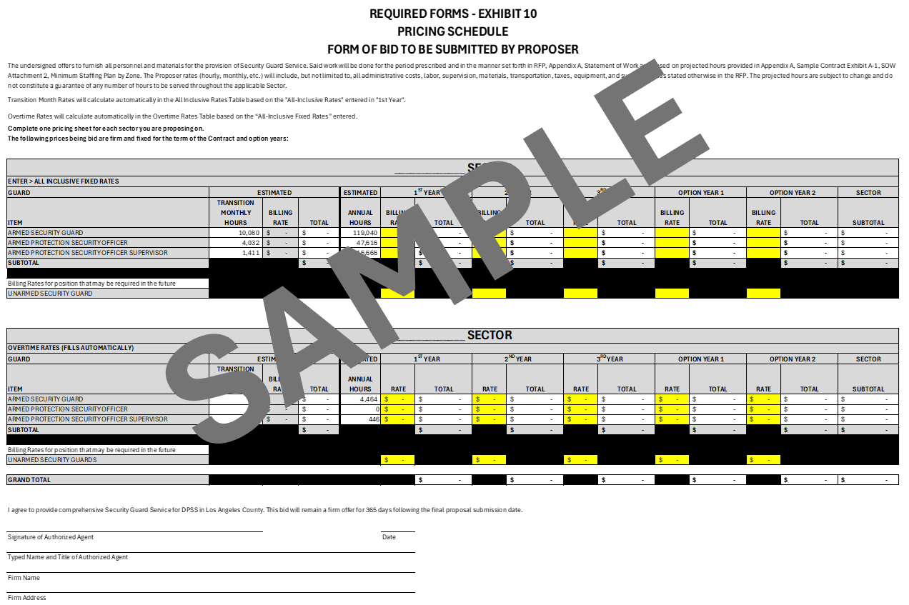

**REQUIRED FORMS – EXHIBIT 11**

**LIVING WAGE PROGRAM**

**APPLICATION FOR EXEMPTION**

The contract to be awarded pursuant to the County’s solicitation is subject to the County of Los Angeles Living Wage Program (LW Program) ([Los Angeles County Code, Chapter 2.201](https://library.municode.com/ca/los_angeles_county/codes/code_of_ordinances?nodeId=TIT2AD_DIV4MIRE_CH2.201LIWAPR)). Contractors and subcontractors must apply individually for consideration for an exemption from the LW Program**. To apply, Contractors must complete and submit this form with supporting documentation to the County by the due date set forth in the solicitation document**. Upon review of the submitted Application for Exemption, the County department will determine, in its sole discretion, whether the contractor and/or subcontractor is/are exempt from the LW Program.

|  |  |  |
| --- | --- | --- |
| Company Name:  Click or tap here to enter text. | | |
| Company Address:  Click or tap here to enter text. | | |
| City:  Click or tap here to enter text. | State:  Click or tap here to enter text. | Zip Code:  Click or tap here to enter text. |
| My business has received an aggregate sum of less than $25,000 during the preceding 12 months under one or more Proposition A contracts and/or cafeteria services contracts, including the proposed contract amount. | | Yes   No |

**I am requesting an exemption from the LW Program for the following reason(s) (*attach all documentation that supports your claim to this form*). Please check all that apply:**

My business is subject to or intends to enter into abona fide Collective Bargaining Agreement *(attach agreement)*; **AND**

the Collective Bargaining Agreement expressly provides that it supersedes all the provisions of the Living Wage Program; **OR**

the Collective Bargaining Agreement expressly provides that it supersedes the following specific provisions of the Living Wage Program (I will comply with all provisions of the Living Wage Program not expressly superseded by my business’ Collective Bargaining Agreement):

|  |
| --- |
| Click or tap here to enter text. |

**REQUIRED FORMS – EXHIBIT 12**

**LIVING WAGE PROGRAM STAFFING PLAN**

Refer to Excel Worksheet for a fillable form

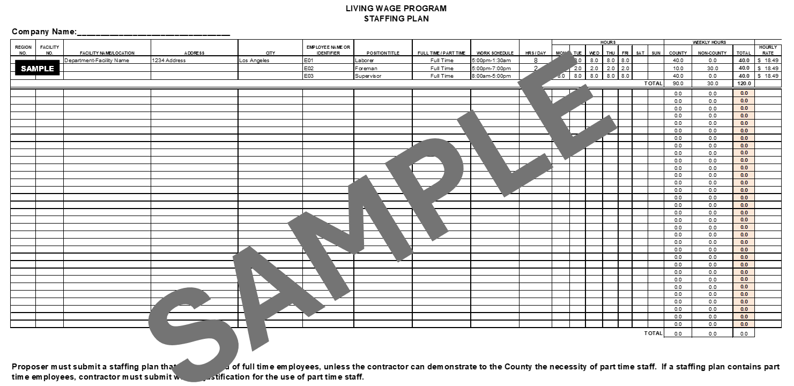

**REQUIRED FORMS – EXHIBIT 13**

**BUDGET SHEET AND BUDGET NARRATIVE**

Refer to Excel Worksheet for a fillable form

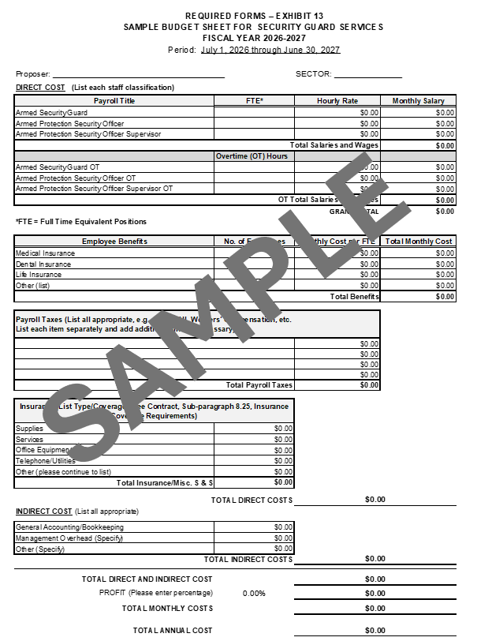

**REQUIRED FORMS – EXHIBIT 14**

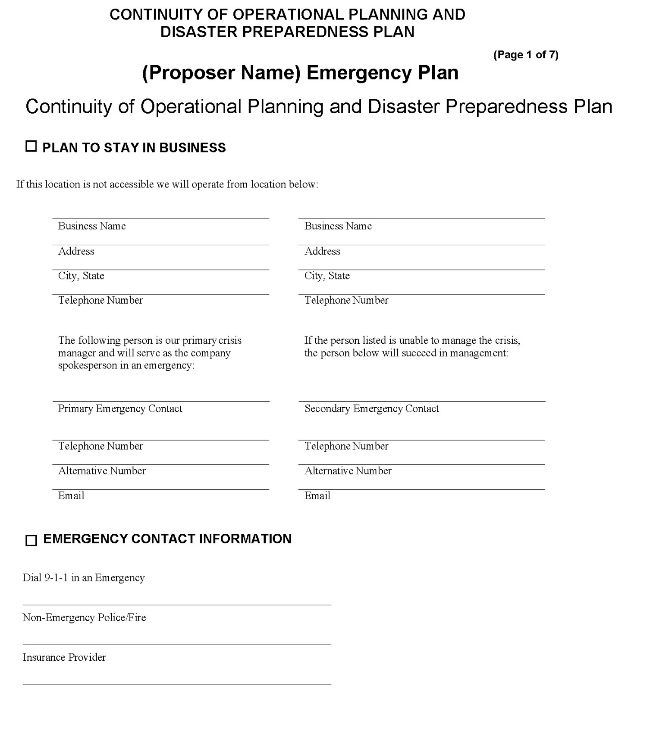

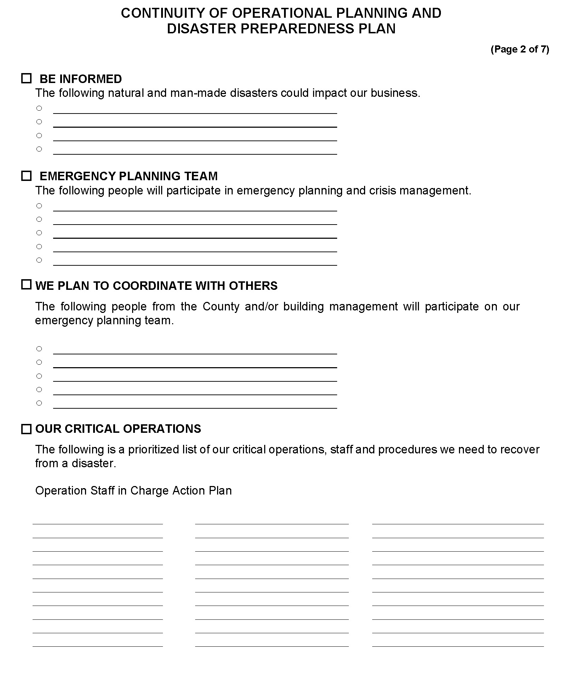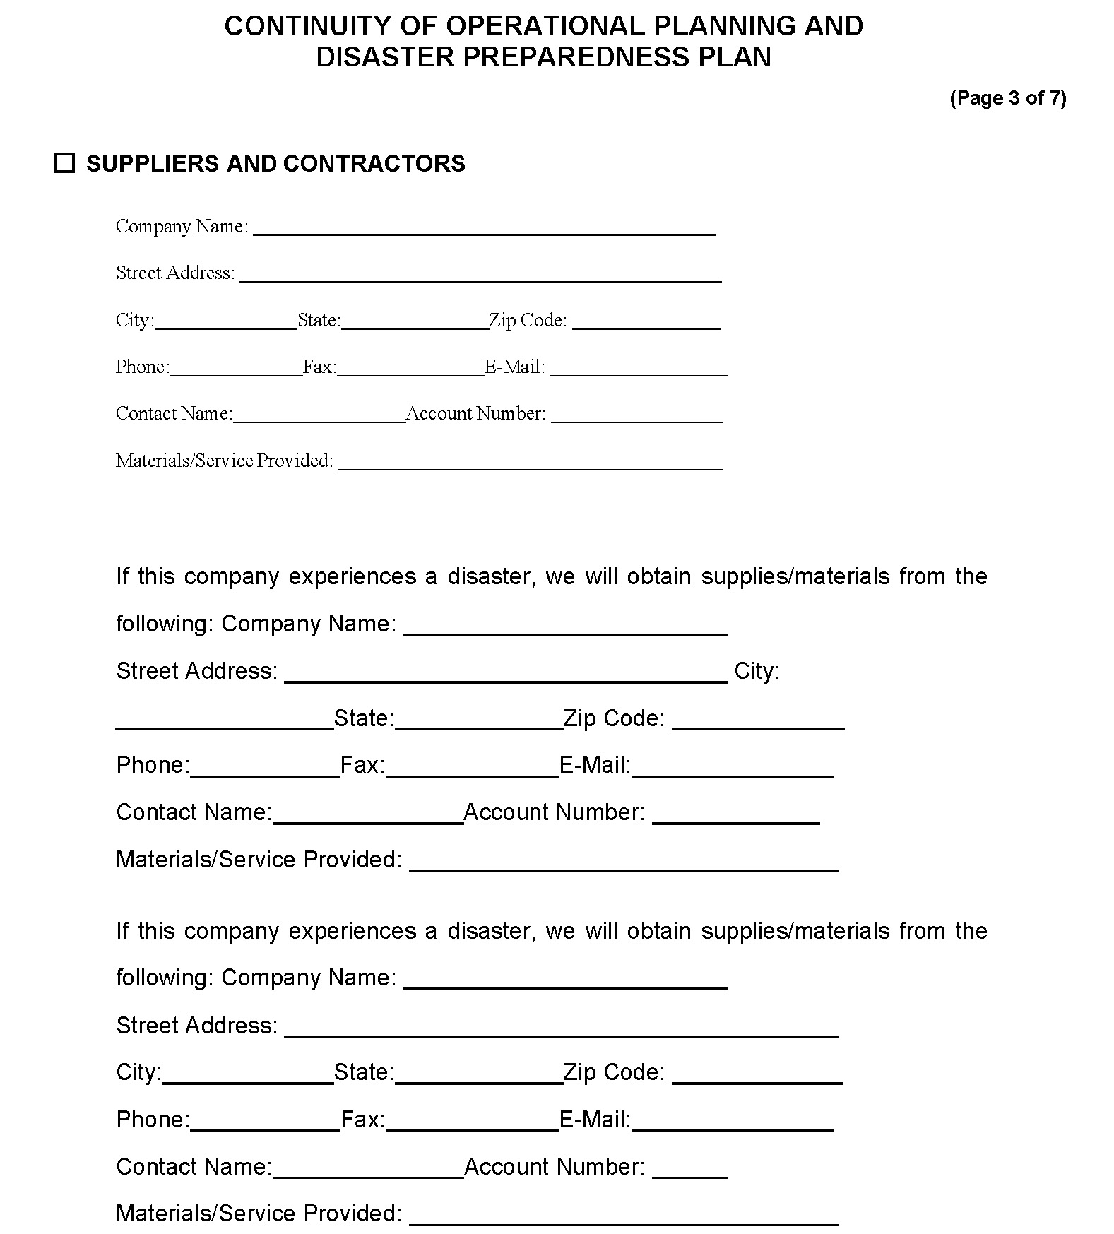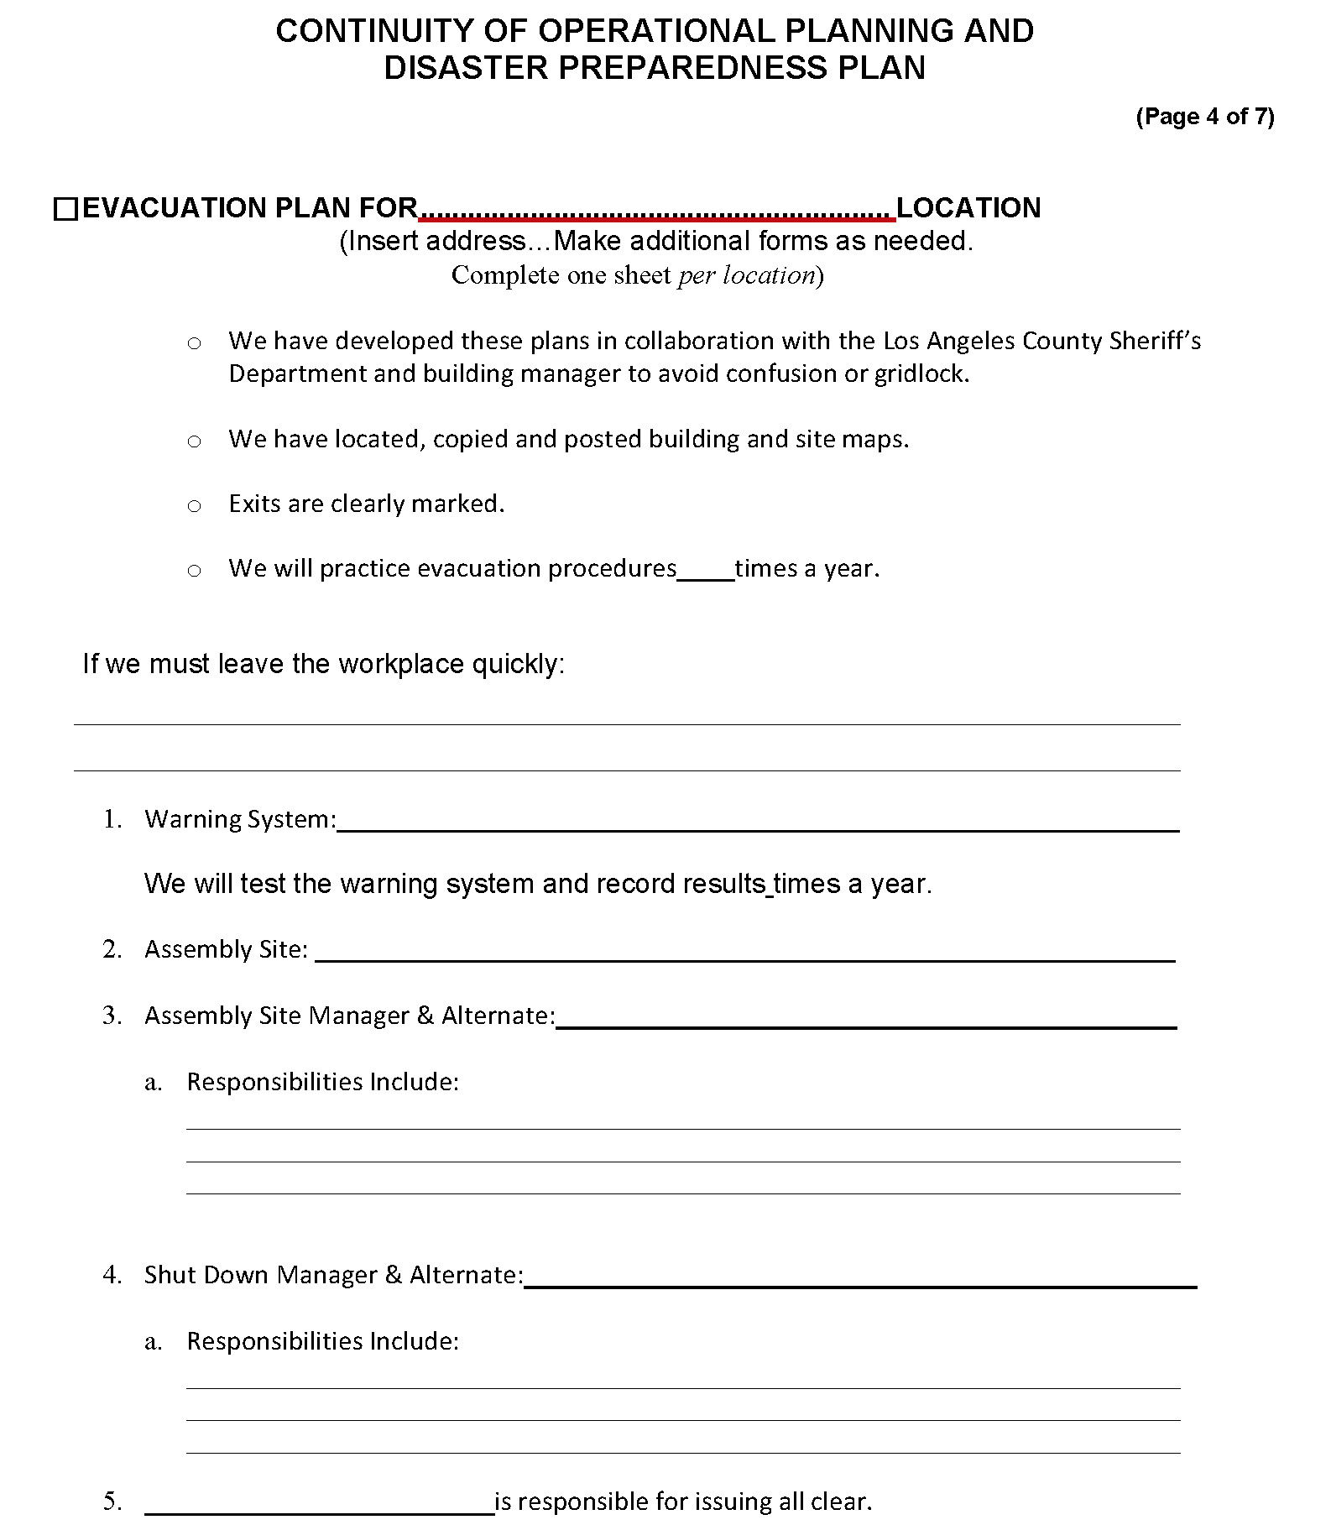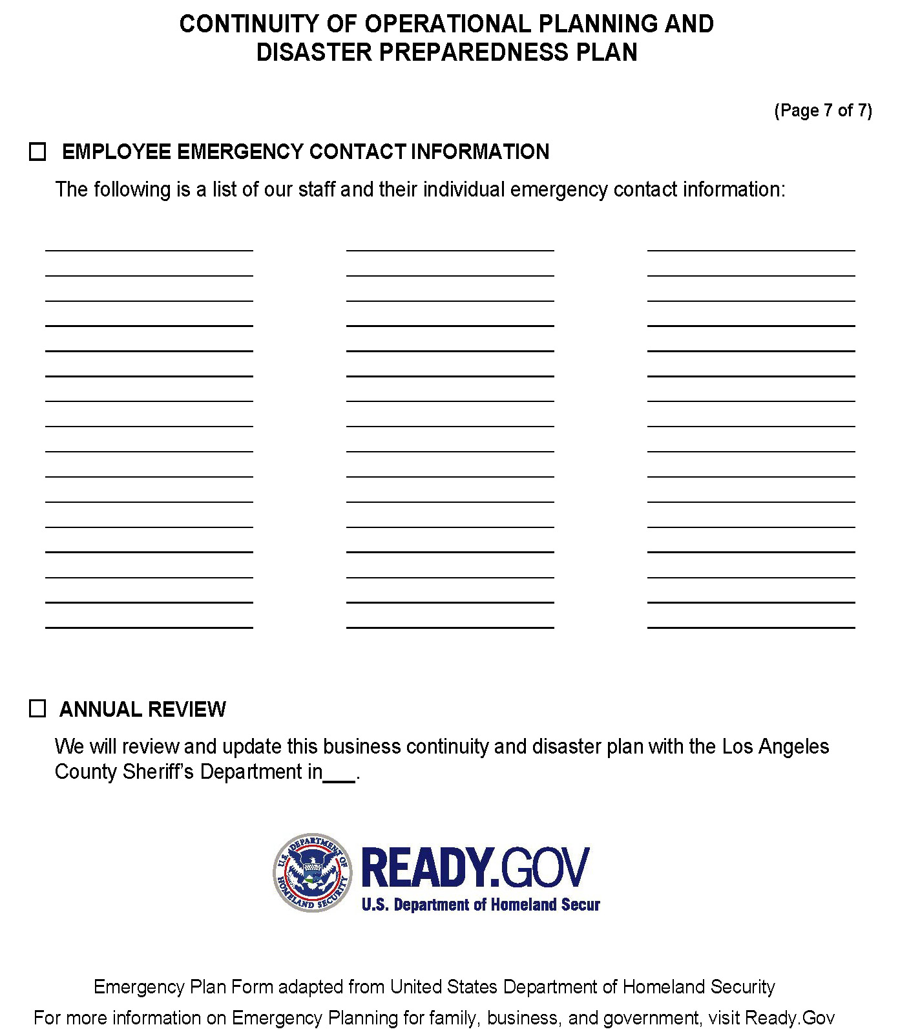

**REQUIRED FORMS – EXHIBIT 15**

**DECLARATION**

**DECLARATION: I DECLARE UNDER PENALTY OF PERJURY UNDER THE LAWS OF THE STATE OF CALIFORNIA THAT THE INFORMATION SUBMITTED IN EXHIBITS 1-14 IS TRUE AND CORRECT.**

|  |  |
| --- | --- |
| PRINT NAME:  Click or tap here to enter text. | TITLE:  Click or tap here to enter text. |
| SIGNATURE: | DATE:  Click or tap here to enter text. |